Lab Exercise 20
Creating a Pipeline Script

Objective: To create a pipeline script for automating build processes in Jenkins

Tools required: Jenkins

Prerequisites: None

Steps to be followed:
- Log in to the Jenkins CI tool and create a pipeline script

Step 1: Log in to the Jenkins Cl tool and create a pipeline script

- Open the browser, go to the Jenkins Dashboard by typing localhost:8080 in your browser, provide the credentials, and click the Sign in button


Note: The credentials for accessing Jenkins in the lab are Username: admin and Password: admin.

- Click on the New Item option as shown in the screenshot below:
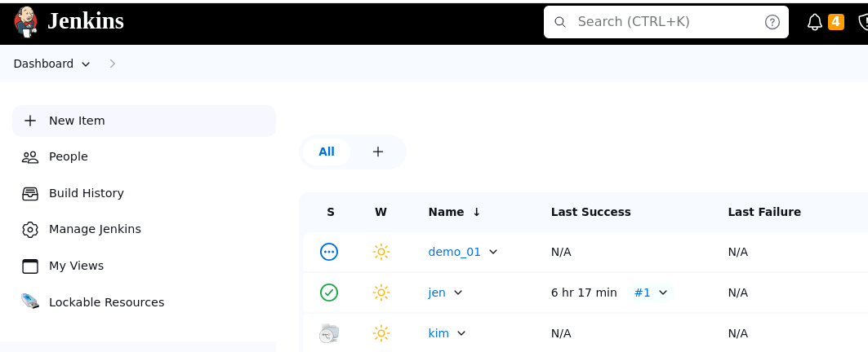

- Enter a desired name for the project, select Pipeline, and then click on OK as shown in the screenshot below:
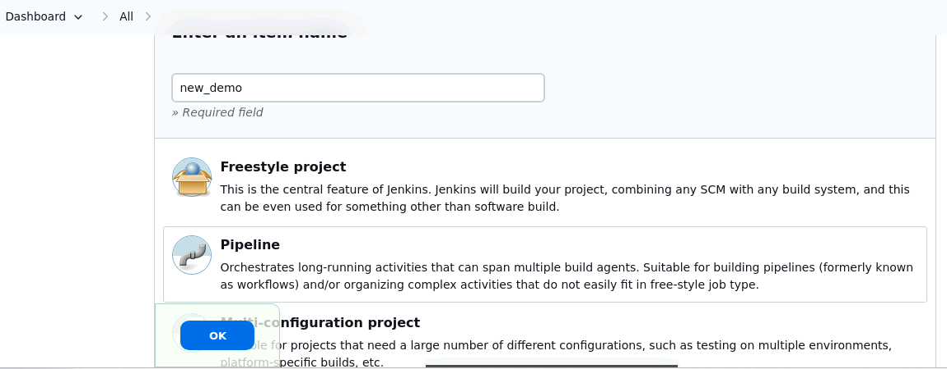

- Click on Pipeline as shown in the screenshot below:

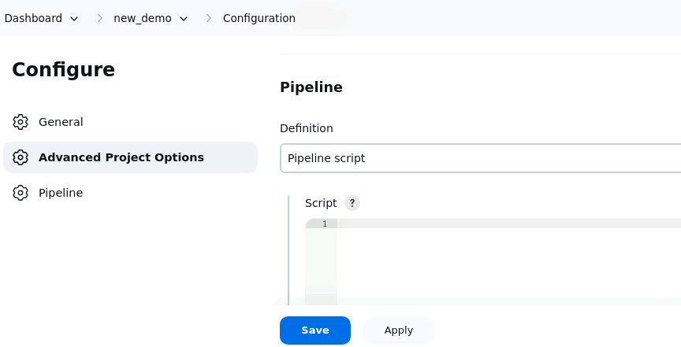

- Enter the following pipeline script in the script editor and click on Save as shown in the screenshot below:
pipeline {
agent any
stages {
stage("hello") {
steps{
echo"welcome to Jenkins pipeline"
}
}
}
}

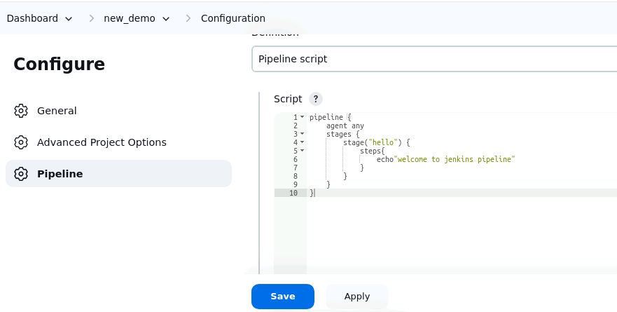

OUTPUT:-
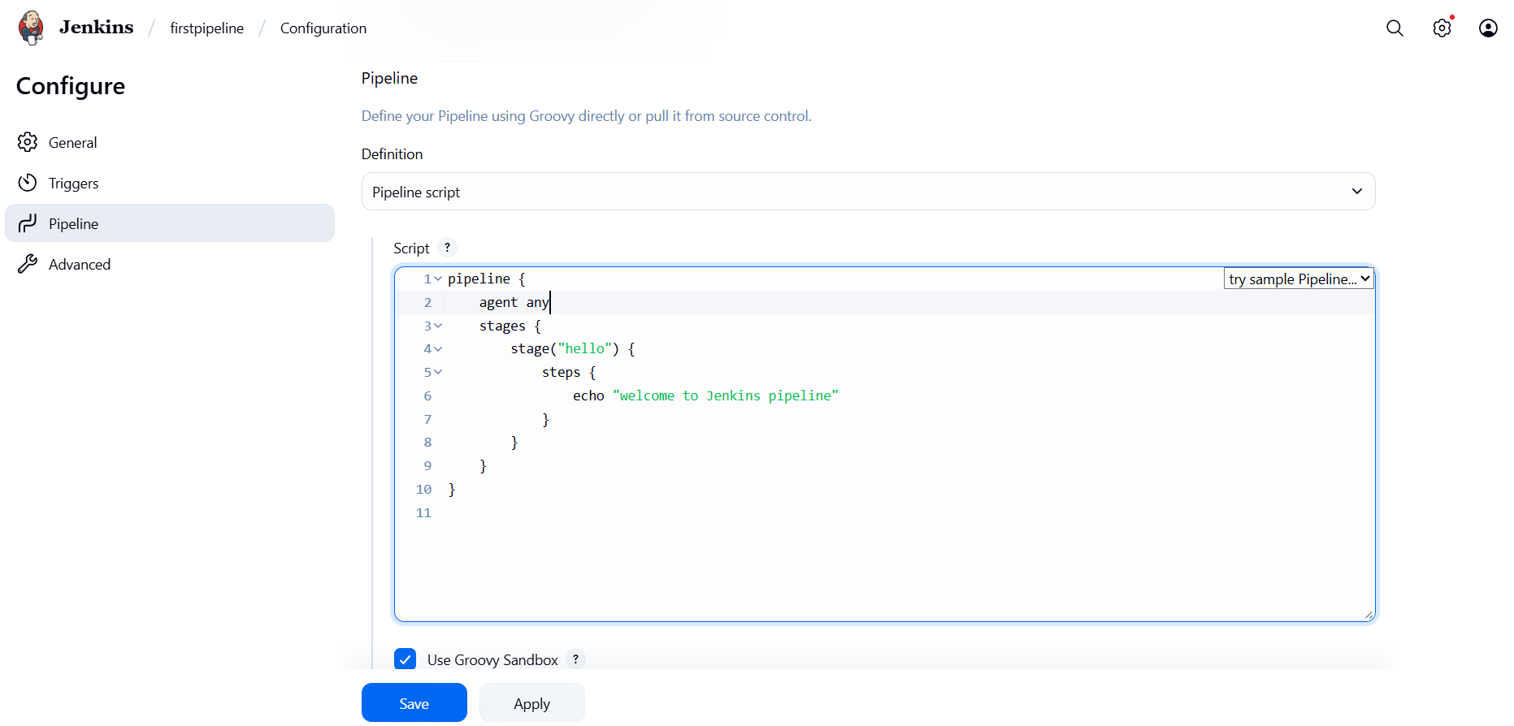

- Click on Build Now to run the pipeline script as shown in the screenshot below:

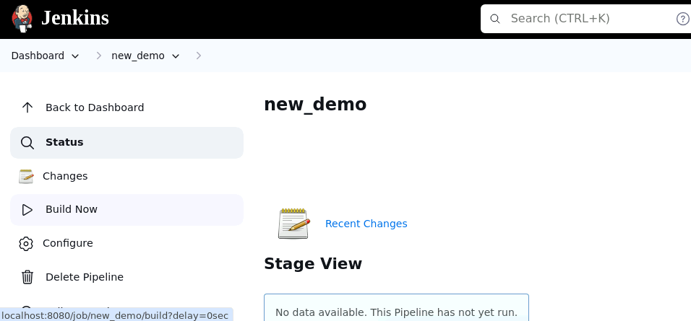

- Hover over the milliseconds number next to the build stage name as shown in the screenshot below:

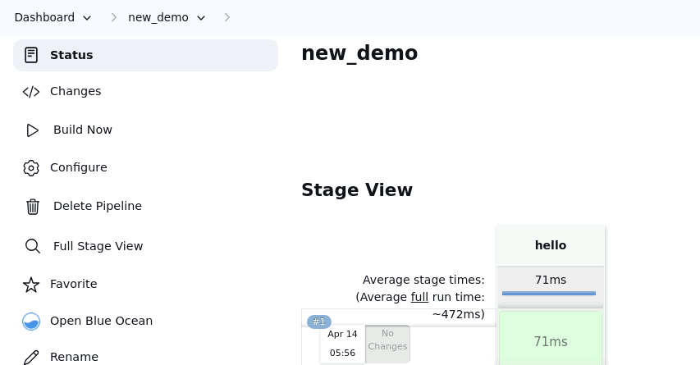

Note: Ensure that you hover the cursor over the milliseconds number without clicking on it

- Click on Logs as shown in the screenshot below:

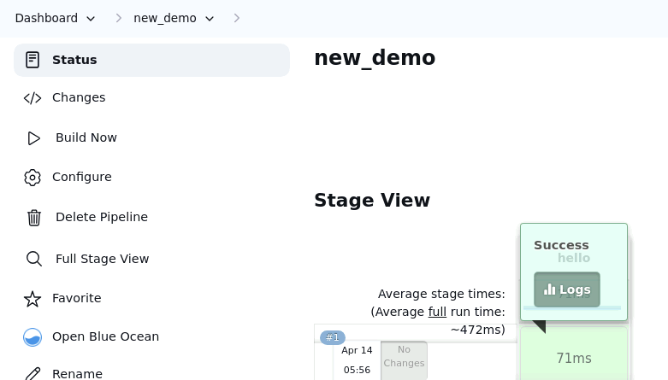

- Check for the message in the top-left corner to confirm the successful execution of the pipeline stage as shown in the screenshot below:

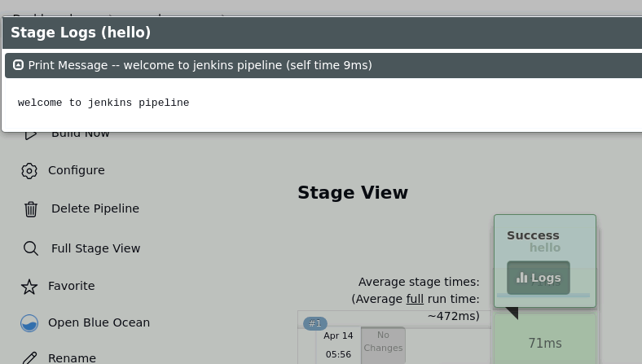

By following these steps, you have successfully created a pipeline script for automating build processes in Jenkins.

Output:
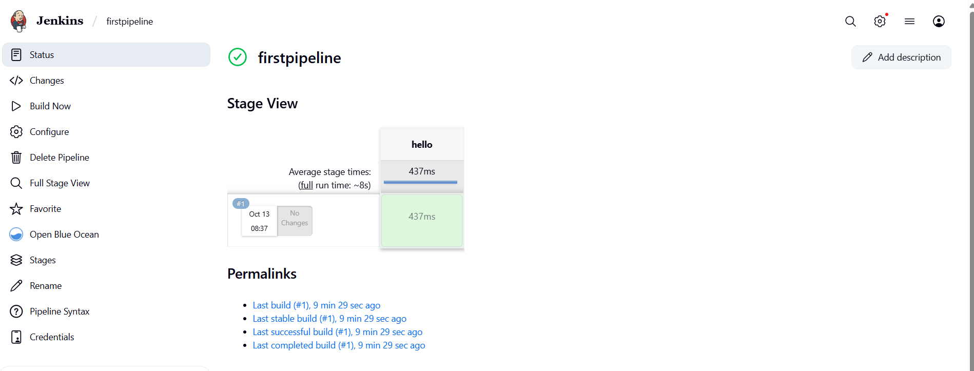

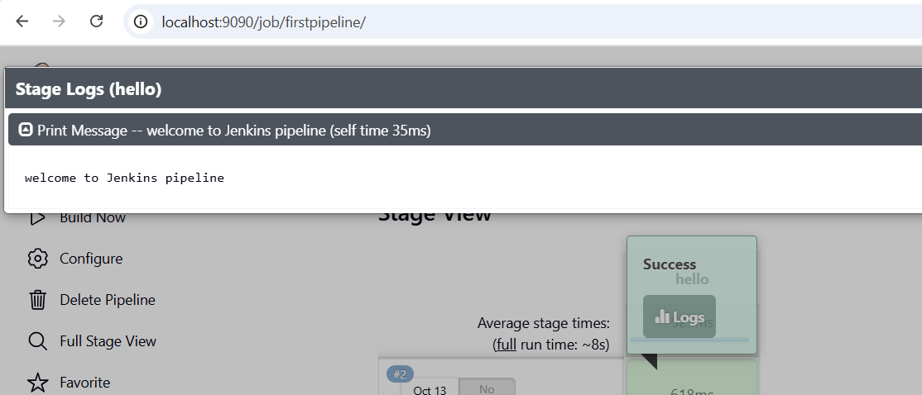

Creating Pipeline For Maven Project

Output:
cloning repo:
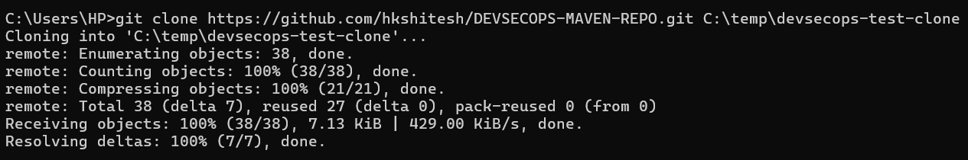

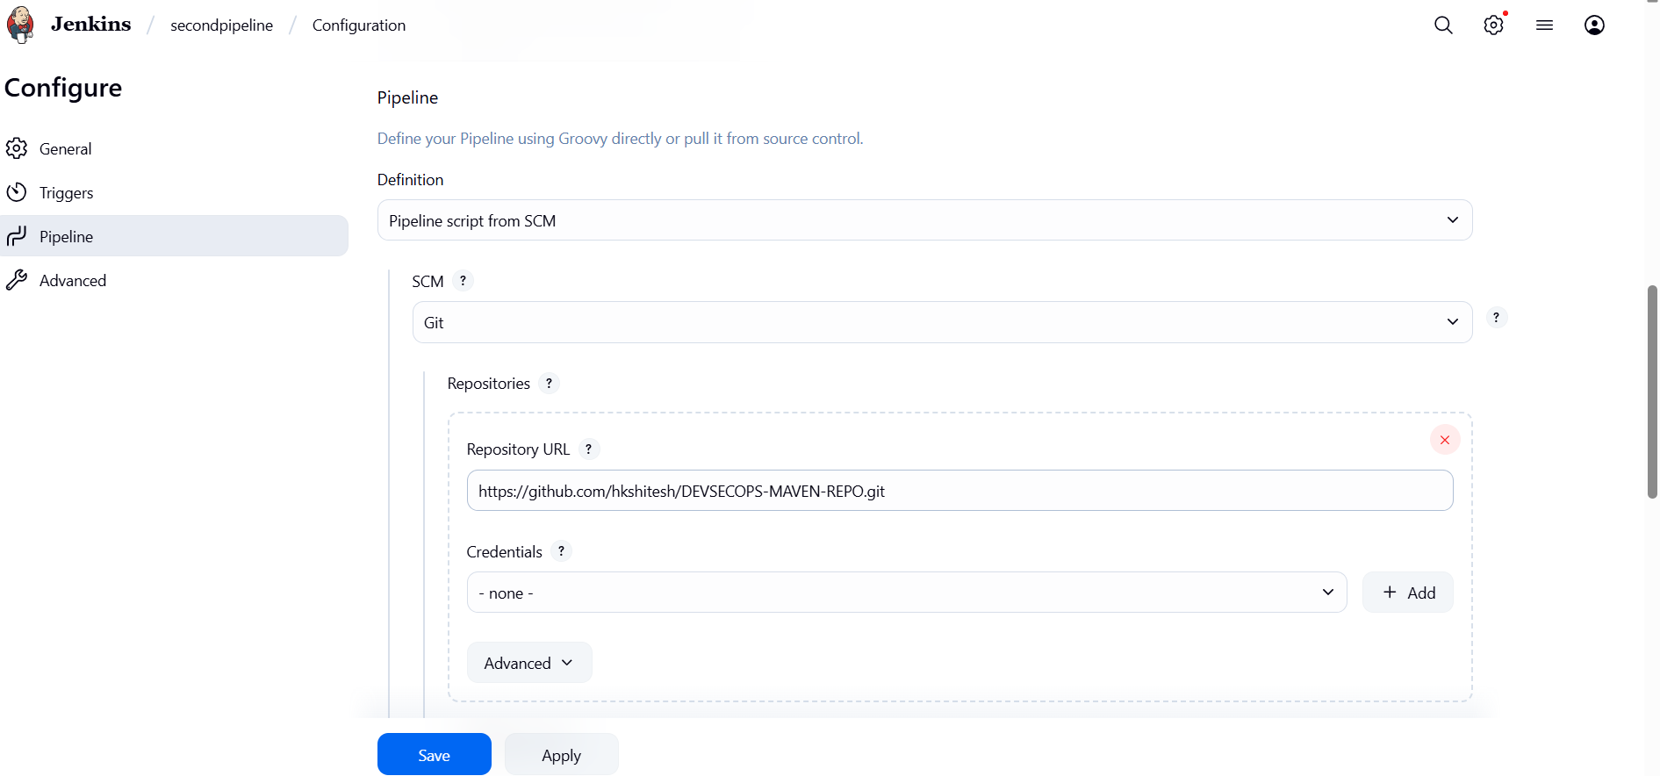
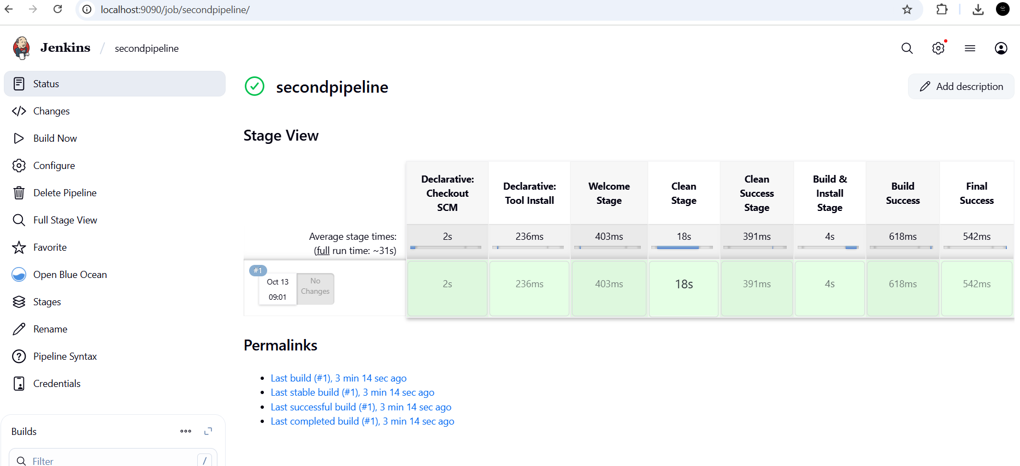

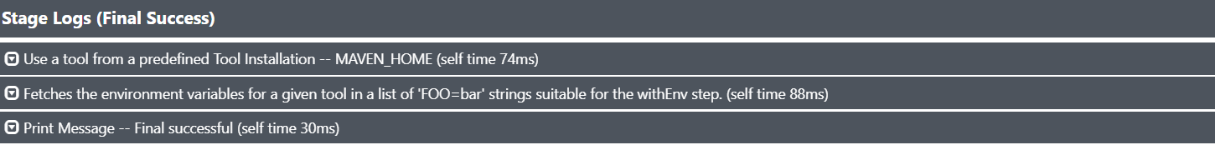

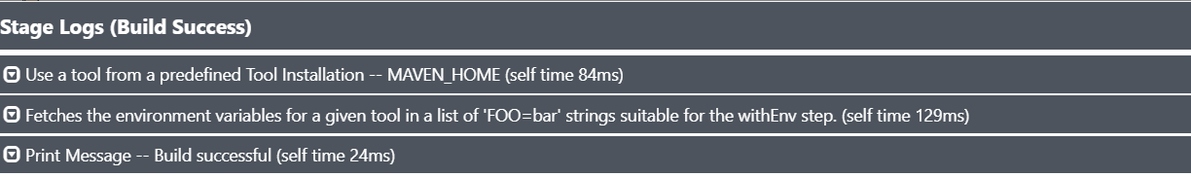

Blue ocean output:
